What Kenyan Rose Farms Should Grow, and for Whom
Oct 9, 2026 · @Edna
Kenyan rose farms should concentrate on four red and white standard roses (Athena, Madam Red, Ever Red and Proud), add an established spray range for the Gulf, and sell both through the 13 buyers who already buy on standing programmes.
A grafted rose plant stays in production for about seven years. A farm that plants the wrong variety lives with that choice long after the market has moved on. Yet more than 70% of Kenya's flowers still leave through one channel, the Netherlands, where the grower rarely meets the final buyer.
This report follows the evidence on 70 rose varieties across nine export markets, and on 42 buyers in those markets. It answers three business problems.
- What to grow. Which varieties have demand in enough markets to justify the greenhouse space?
- Where to send it. Does one assortment suit every market, or does each market want a different rose?
- Who to sell to. Which buyers will commit to weekly standing orders instead of spot purchases?

Problem 1: Too many varieties chase too little proven demand
Demand is concentrated in very few roses. Seven of the 70 varieties account for 30 of the 53 published links between a variety and a market, which is 57% of the evidence from 10% of the range.
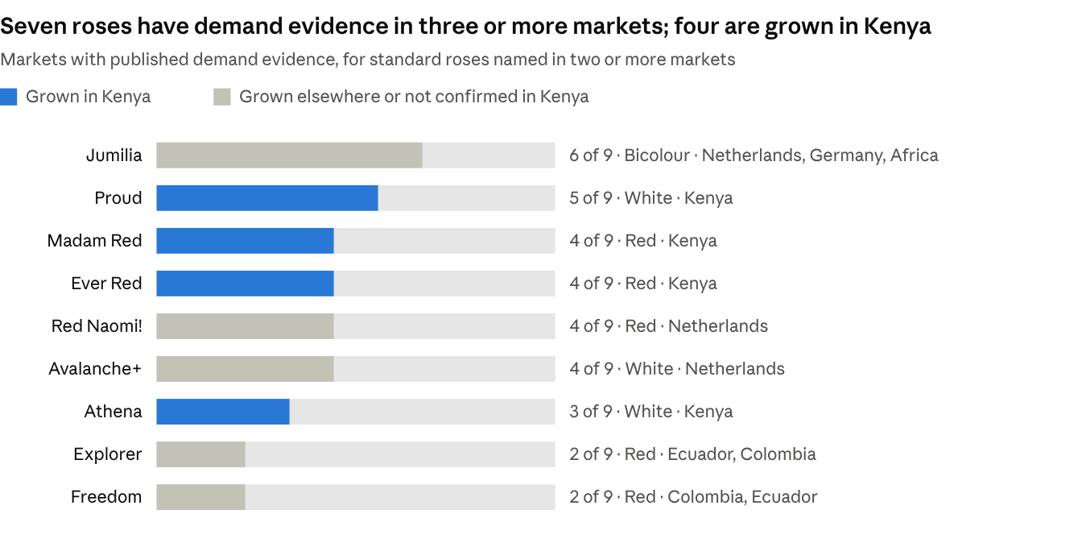
Rose varieties dataset · 31 standard roses checked against 9 markets · 9 October 2026
The three leading import roses at the Dutch auction, Athena, Madam Red and Ever Red, are all Kenyan-grown. Proud, a white rose, adds the Gulf and Russia. The roses Kenya does not grow tell their own story: Red Naomi! and Avalanche+ are Dutch greenhouse roses, and Explorer and Freedom come from Ecuador and Colombia.
The long tail is where the risk sits. Eleven of the 31 standard roses had no market named in any source, even though breeders promote several of them as top varieties.
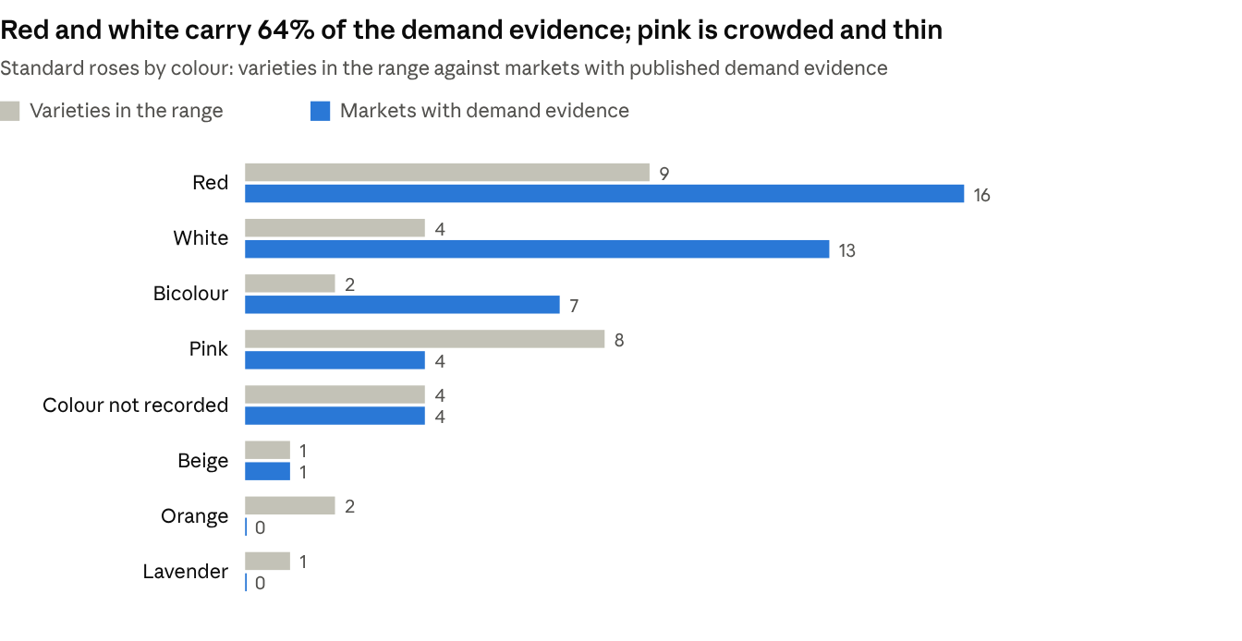
Rose varieties dataset · 31 standard roses, 45 published variety-to-market links · 9 October 2026
Colour explains much of the gap. Pink is the second most crowded colour with eight varieties, yet it has only four market links, all in Russia and none for a rose confirmed as Kenyan-grown. Orange and lavender have no market evidence at all. A farm that fills a greenhouse with fashionable colours is betting against where the evidence points.

Problem 2: One assortment does not fit every market
Each region asks for a different rose, so a farm has to choose its markets before it chooses its varieties.
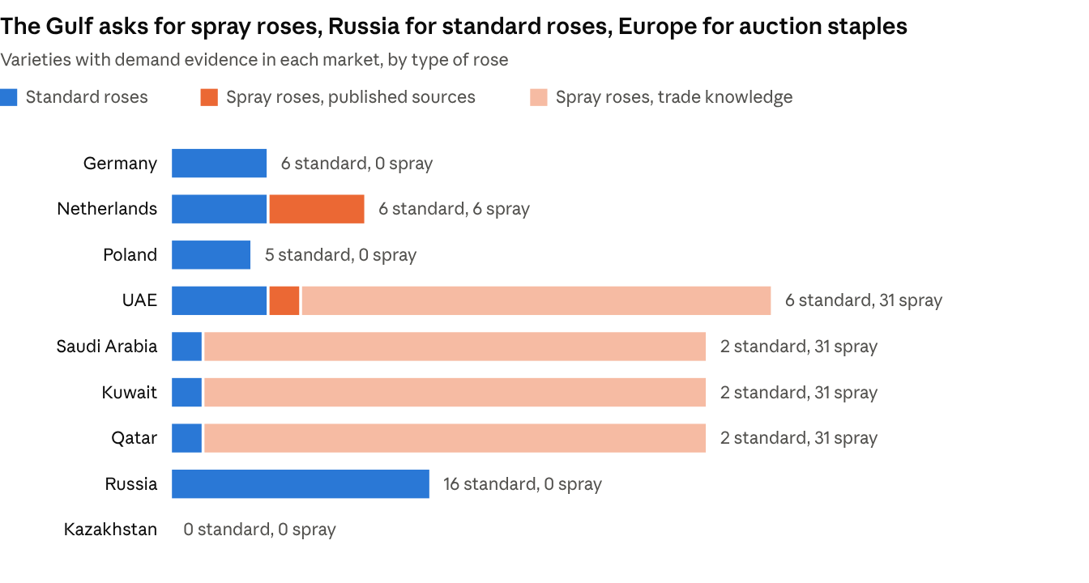
Rose varieties dataset · 70 varieties, 9 markets · published sources plus first-hand trade knowledge for Gulf spray roses · 9 October 2026
Europe buys the auction staples. Germany, the Netherlands and Poland share the same five roses: Red Naomi!, Avalanche+, Athena, Madam Red and Ever Red. The supermarket range is the intermediate rose with a 4 to 5 cm head, and in Germany about one rose in three carried the Fairtrade label in 2024. This is a volume market for productive reds and whites, not for novelties.
The Gulf buys spray roses and white. Thirty-one established spray varieties are in good demand there according to first-hand trade knowledge, and eight of them are also confirmed by Kenyan growers or a Gulf wholesaler. Among standard roses, the breeder of Proud calls it a big hit in the Middle East, and about 70% of African-grown Jumilia is reported to go there. The premium red in the UAE is Explorer from Ecuador; Kenyan reds serve everyday retail and events.
Russia buys big heads, and Kenya competes on price. Sixteen standard roses are named for Russia, but only five are Kenyan-grown: Proud and four low-cost 40 cm lines. The other eleven are mostly Dutch or large-headed South American roses such as Explorer, Freedom, Mondial and Pink Floyd.
Kazakhstan is a blind spot. No source names a single variety for it. Ecuador supplied about 42% of its flower imports in 2025, and Kenya ranked fifth.

Problem 3: Too few buyers are ready for standing orders
The right rose still needs a buyer who orders it every week. Of 42 buyers identified across the nine markets, only 13 already buy on fixed programmes or order from Kenyan farms weekly.
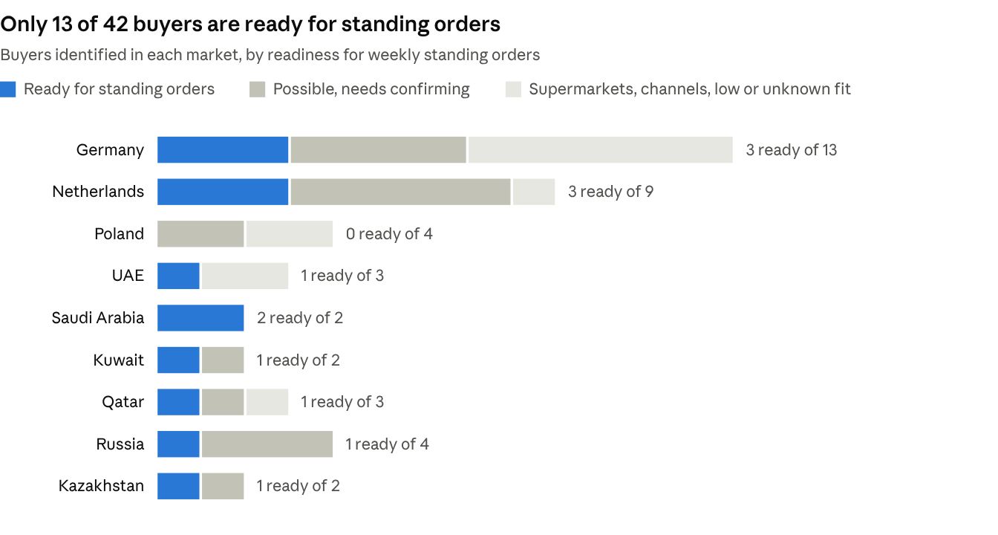
Buyer dataset · 42 buyers in 9 markets · readiness is the analyst's rating from published evidence · 8 October 2026
The biggest market is not the easiest one. Germany has the most buyers, but nearly half are supermarkets, intermediaries or importers with no known Kenya link. The supermarkets buy through importers and effectively require Fairtrade certification. The Gulf is the opposite: 10 buyers, and 5 of them ready. Poland has none.
Ten of the 42 buyers show no sign of buying from Kenya today. And at the Dutch auction, 43% of flowers still sell through the clock, which is a spot price and not a standing order. A farm that relies on the clock has no say over next week's price.
The 13 buyers worth approaching first are few enough to name:
Market | Buyers ready for standing orders
Germany | Omniflora, Landgard, Blütenpracht
Netherlands | Dutch Flower Group, Rosalink, Decofresh Roses
UAE | Floranow
Saudi Arabia | United Flower Group, Floranow KSA
Kuwait | Floward
Qatar | Plaza Hollandi
Russia | Grand Flowers Group
Kazakhstan | Art Flowers

What farms should concentrate on growing
The three problems point to one answer: grow fewer varieties, match them to a chosen market, and plant against a named buyer.
Market | Standard roses to concentrate on | Spray roses | Buyers to approach first
Europe (Germany, Netherlands, Poland) | Athena, Madam Red, Ever Red | Fireworks, Summerdance, Tralala and Odilia, which Kenyan growers already sell through the Netherlands | Omniflora, Landgard, Blütenpracht, Dutch Flower Group, Rosalink, Decofresh Roses
Gulf (UAE, Saudi Arabia, Kuwait, Qatar) | Proud, Ever Red, Madam Red | The established range, led by Snowflake, Mirabel, Fireworks, Summerdance, Tralala, Odilia, Reflex and Dinara | Floranow, United Flower Group, Floward, Plaza Hollandi
Russia and Kazakhstan | Proud, plus a low-cost 40 cm line | No evidence yet | Grand Flowers Group, Art Flowers
Three choices follow from the evidence.
- Build the core on red and white. Athena, Madam Red, Ever Red and Proud are Kenyan-grown and between them reach eight of the nine markets.
- Treat spray roses as the Gulf specialism. It is the one region where a wide spray range has known demand, and it holds 5 of the 13 ready buyers.
- Hold back on pink, orange and lavender standard roses unless a buyer has asked for them by name. Orange and lavender have no market evidence, and what exists for pink belongs to Dutch and Ecuadorian roses.
Jumilia deserves a closer look. It has the widest reach of any rose in the data, six markets, but it is not confirmed as grown in Kenya.

What to do next
A farm can act on this before its next replanting, in five steps.
- Audit the greenhouse. List every variety beside the buyer and market it is grown for. Any variety with no named buyer is a candidate for replacement.
- Choose one or two target markets. Match the range to the table above instead of spreading thinly across all nine.
- Open conversations with the 13 ready buyers. Ask each what they order every week, by variety and stem length.
- Decide on Fairtrade. It is the entry ticket to German supermarket programmes.
- Close the blind spots. For Kazakhstan, Poland and the smaller Gulf states, ask buyers directly before planting for them.

What this evidence cannot tell you
The analysis shows where demand is documented, not how many stems are sold. No public source ranks rose sales by variety and country. Gulf spray demand rests on first-hand trade knowledge, and buyer readiness is a rating made from public information. Treat the findings as a shortlist to test with buyers before replanting.

Sources
- AIPH FloraCulture International: leading Dutch and import roses
- AIPH FloraCulture International: Jumilia
- Thursd: The Beauty of Kenyan Roses
- Thursd: Top 10 Rose Varieties Kenya Versus Ecuador
- Thursd: bud sizes in roses
- Thursd: Isinya Roses and Pride of Africa spray roses
- Black Tulip Group: red roses for UAE florists
- EastRussia: rose varieties and florists' choice
- Nation: Kenya exports over 1bn stems to Amsterdam
- Business Daily: Kenya eyes direct flower exports to Gulf countries
- Fairtrade Germany: roses in 2024
- top agrar: roses from Kenya
- Azattyq Ruhy: Kazakhstan flower imports 2025
The full evidence for each variety and buyer, with its own source link, is in the two spreadsheets: Rose_varieties_by_market and Kenya_flower_buyers_dataset.

